
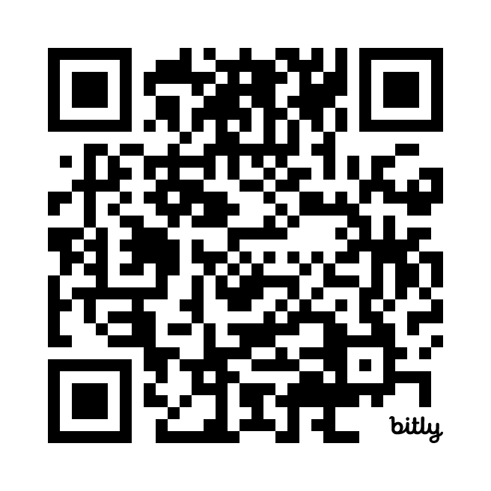
Showcase of Creativity
Celebrating Extraordinary People

Do you draw, paint, take photos, make films, write, act, sing, dance, play music or do anything else creative? We need YOU!
At Access to Industry we meet creative people every day and, to celebrate you, we have decided to have our first ever Showcase of Creativity. We are planning a day of exhibits, performances and workshops to share the fantastic things you do and we would like you to submit your work.
Want to be more hands on? Why not volunteer...or do both?!
Submitting Work/PerformANCE
If you would like to submit work or arrange a spot for a performance/reading, simply fill in the Submission Form below with your contact details and what you want to showcase and hand it into reception at:
Access to Industry, 156 Cowgate, Edinburgh EH1 1RP.
Not in Edinburgh? This form can be returned by email or ask your caseworker for a paper copy to fill in by hand and send a photo of it by WhatsApp to 07514666043.
Still no luck? Text ‘Submit Work’ with your name to 07514666043 and we’ll get back to you.
Submission guidelines are on our website and can be provided by WhatsApp, email, text or on paper.
We will get in touch after the Intention to Submit Deadline on Monday 19th July for more details of your submission/performance. You do not need to submit any work now but should have physical art ready to bring/send to us by Monday 5th August 2024.
Volunteering
If you would like to volunteer just fill in your contact details on the Submission Form below and tick ‘I want to volunteer!’ and we will get in touch after the submission deadline and let you know how you can help.
NEED MORE COPIES OF THIS FORM? Use this link or scan the QR code:
https://accesstoindustry.co.uk/showcase-of-creativity-we-need-you/

 | Submission Form
 | Intention to Submit DEADLINE Friday 19th July 2024 - DO NOT SEND ANY WORK NOW!
 | SUBMISSION of work between Monday 5th August and Friday 9th August 2024
 | Name: |  |  | Caseworker:
 | Phone No.: |  |  | Email Address:
What I would like to submit
Please note that due to time and space restrictions we may not be able to feature all your work so when we have received all the Submission Forms we will ask you to prioritise which pieces you wish to showcase.
 |  | Submission |  |  |  |  | Number of Pieces
 |  | Writing/Spoken Word - Limit 3 pieces
 |  | Visual – Static Artwork/Photography - Limit 2 pieces (We can print photos)
 |  | Visual - Video/Moving Image - Limit 1 video
 |  | Performance - Limit 1 piece* (*It may be possible to join other group performances)
 |  | I want to volunteer! ☐
 |  | Next Step:
Hand in form at 156 Cowgate, Edinburgh EH1 1RP
or send by email to helenmurray@accesstoindustry.co.uk or WhatsApp a photo to 07514666043

